Over The Wire

## Level 19 to Level 20

**Step 1: SSH Login**

**Password:** **cGWpMaKXVwDUNgPAVJbWYuGHVn9zl3j8**

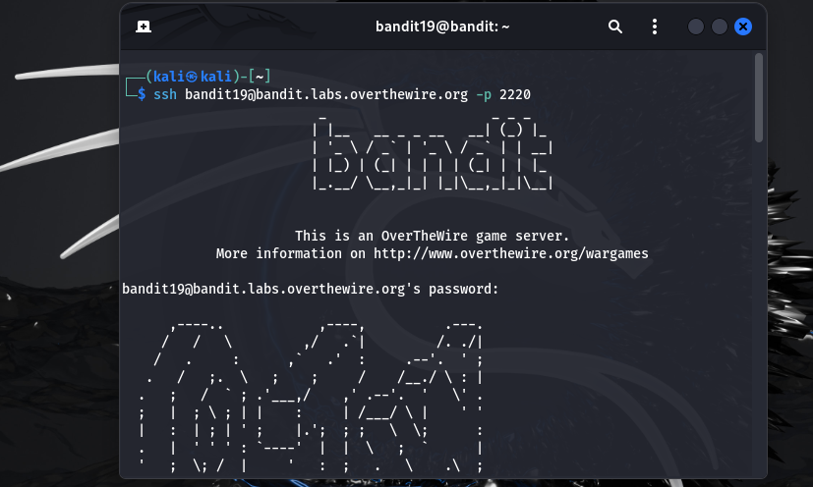

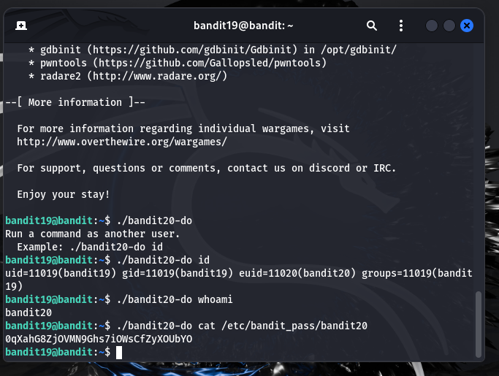

**Password**: 0qXahG8ZjOVMN9Ghs7iOWsCfZyXOUbYO